
Repository Upgrade Guide

© 2001 - 2006 Pentaho

http://www.pentaho.org

Table of contents
1. Repository Upgrade GUIDE 3
1.1. What is a repository 3
1.2. Upgrading 3

Repository Upgrade Guide

What is a repository
A Kettle repository is a set or database tables that are being accessed by the Kettle clients (Spoon, Chef, Pan & Kitchen) to store and retrieve transformations, jobs, database connections, etc.

Upgrading
When upgrading Pentaho Data Integration, it is possible that you'll be asked by the repository login window to upgrade the repository. This process should run automatically in most cases. Sometimes however, you might need to take additional steps.
Here are the steps we advice you to take:

- Make a backup of the repository database. Ask your DBA if you don't know how to do this.
- Export the complete repository using the repository explorer or Pan (See also: Spoon-2.3.pdf or Pan-2.3.pdf)
- Try to upgrade using the Create or upgrade button in the repository dialog. Go there using the edit button in the repositories dialog:
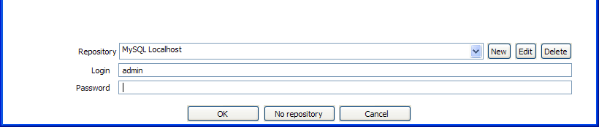
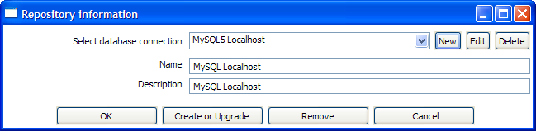

NOTE: You need to confirm the upgrade and enter the admin password for the repository.
If this upgrade goes as expected, you can now use the repository. If not, go to the next step.
- Create a new repository on a different schema or database connection.
- Import the repository using the repository explorer. See also: Spoon-2.3.pdf
- Although the repository import has been tested extensively, you can always report problems with the import at http://kettle.javaforge.com They will be treated with high priority.

